Problem 1:

To check your program, do the following very simple run. Let particle 1 be initially resting at Let particle 2 collide into it with velocity from the initial position Take DT=0.01. Run about 10,000 time step and graph the x-coordinate of both particle every 50 or 100 time-steps:
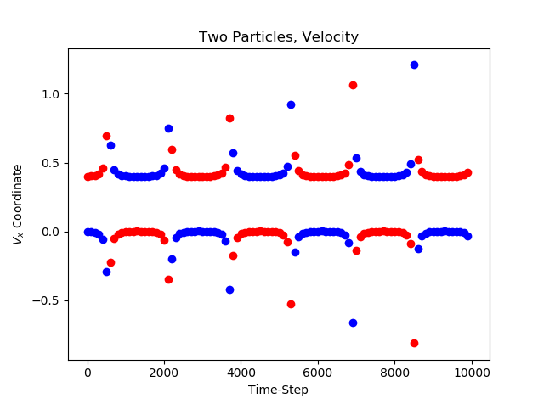
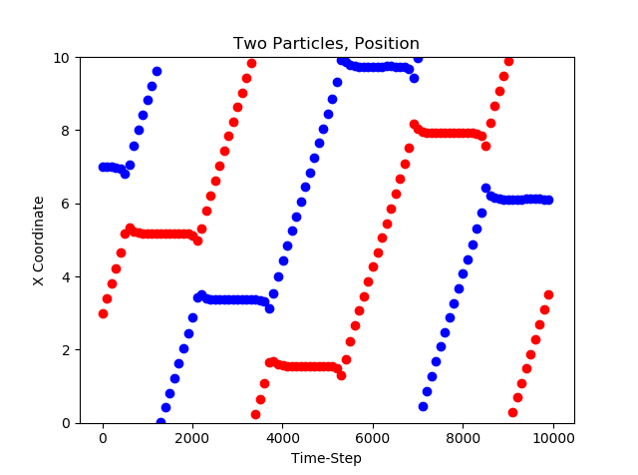
Graph also the velocity of both particles:

Finally, plot out also the total energy, the kinetic energy, and the potential energy all in one graph:
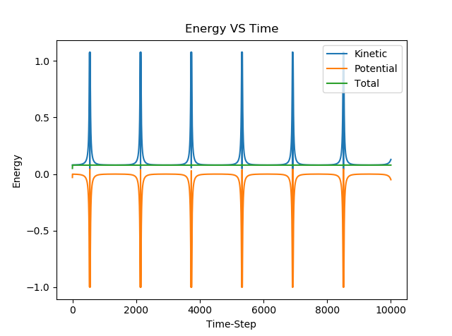
Compared to the initial energy, how accurately is energy conserved? What kind of scattering is being simulated?

As can be clearly seen from the energy graph, total energy is entirely conserved. Hence this is simulating elastic scattering.

Problem 2:

Now run your program from a cold start, with N=27, SX=SY=SZ=6.0, by placing particles in a staggered checker-board pattern, with 9 particles in each 3 layers. Plot the total energy, the kinetic energy, the potential energy and the continuous time average of the kinetic energy all on the same graph as a function of time, for 10,000 to 15,000 time steps:

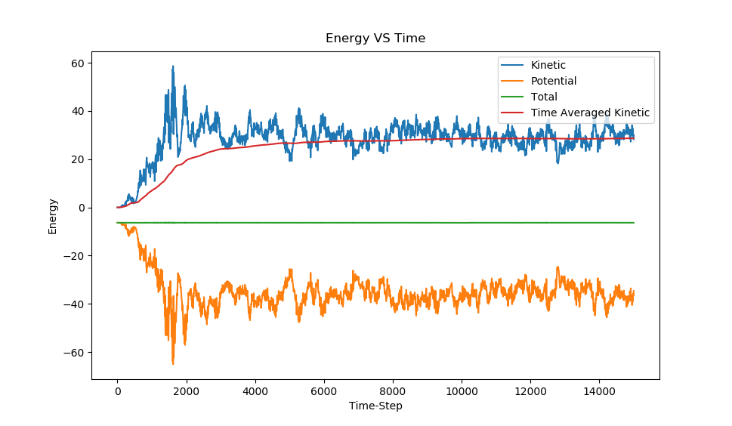

How many time steps are required for the average kinetic energy to settle down to a steady value?

It takes approximately 4000-4500 time-steps for the time-averaged kinetic energy to approach the value K → 28.7

Find the corresponding dimensionless temperature T:

